Assessment Schedule – 2016

Calculus: Apply differentiation methods in solving problems (91578)

Evidence Statement
Q1 | Expected Coverage | Achievement  (u) | Merit  (r) | Excellence  (t)
(a) | 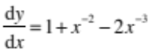 | Correct solution
(b) | 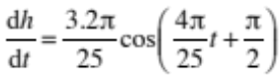  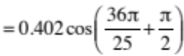  = 0.395 metres per hour | Correct solution with correct derivative
(c) | 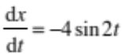  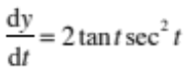  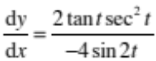  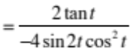  At 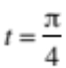, 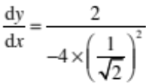  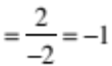 | Correct 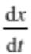 or  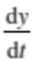 | Correct solution with correct derivatives.
(d) | 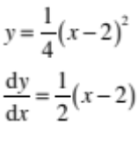  At Q (6, 4) 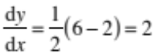  At P 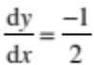  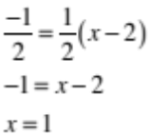 | At P | Correct solution with correct derivative.
(e) | 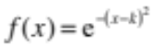  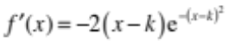  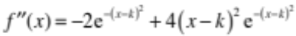  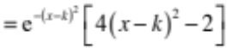  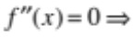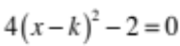  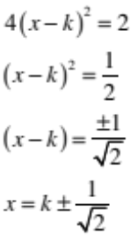 | Correct 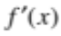 | Correct 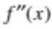 | Correct solutions with correct and

NØ | N1 | N2 | A3 | A4 | M5 | M6 | E7 | E8
No response; no relevant evidence. | ONE answer demonstrating limited knowledge of differentiation techniques. | 1u | 2u | 3u | 1r | 2r | 1t with minor error(s). | 1t

Q2 | Expected Coverage | Achievement  (u) | Merit  (r) | Excellence  (t)
(a) | 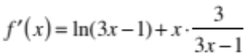 | Correct derivative
(b) | 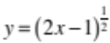  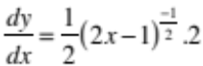  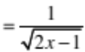  At x = 5 , 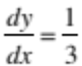 | Correct solution with correct derivative.
(c)(i)  (ii) | 1: –1, 1  2: –2, –1, 1, 4  3: –4, 3, x > 4  4:  1 | 2 correct answers. | 3 correct answers.
(d) | 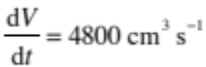  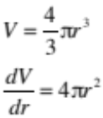  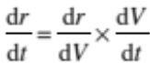  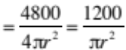  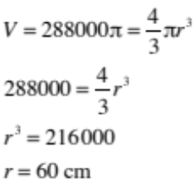  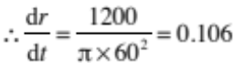cm s^{–1} | Correct expression for 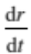 | Correct solution with correct – units not required.
(e) | 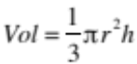  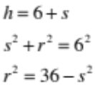  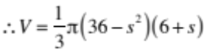  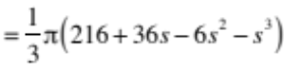  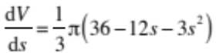  Max volume when 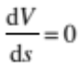  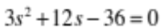  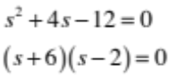  or |  | Correct expression for  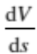 | Correct solution.

NØ | N1 | N2 | A3 | A4 | M5 | M6 | E7 | E8
No response; no relevant evidence. | ONE answer demonstrating limited knowledge of differentiation techniques. | 1u | 2u | 3u | 1r | 2r | 1t with minor error(s). | 1t

Q3 | Expected Coverage | Achievement  (u) | Merit  (r) | Excellence  (t)
(a) | 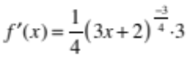 | Correct derivative.
(b) | 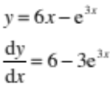  Want 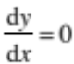  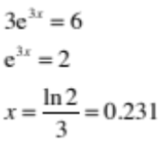 | Correct solution with correct derivative.
(c) | 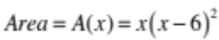  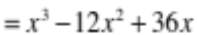  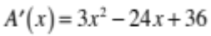  Max when 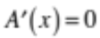  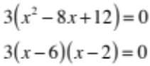  Max when  Max Area = | Correct expression for  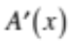 | Correct solution for maximum area with correct derivative.
(d) | 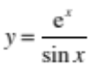  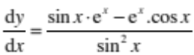  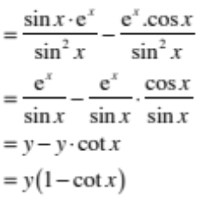 | Correct expression for 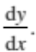 | Correct proof with correct derivative.
(e) | 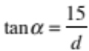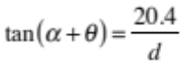  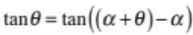  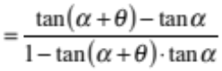  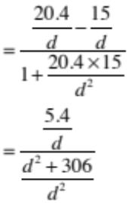  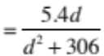  Max when 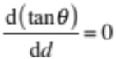  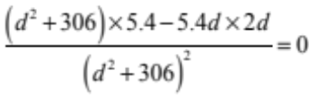  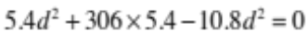  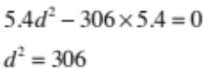  d = 17.5 m |  | Correct expression for  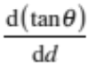  or 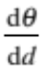 | Correct solution – units not required.

NØ | N1 | N2 | A3 | A4 | M5 | M6 | E7 | E8
No response; no relevant evidence. | ONE answer demonstrating limited knowledge of differentiation techniques. | 1u | 2u | 3u | 1r | 2r | 1t with minor error(s). | 1t

Cut Scores
Not Achieved | Achievement | Achievement with Merit | Achievement with Excellence
0–7 | 8–12 | 13–18 | 19–24

